Steel Surface Defect Detection and Classification
Comprehensive Project Report Aligned to Presentation and Paper Rubrics
Prepared from the attached project plots, evaluation artifacts, and pipeline scripts.
Scope covered: problem framing, dataset design, preprocessing, exploratory analysis, model pipelines, validation strategy, results, findings, and project impact.
Executive summary. The project evaluates two complementary deep learning approaches for steel surface inspection: an image-level classification pipeline using EfficientNet transfer learning and an object-detection pipeline using YOLO. The available evidence shows a balanced classification dataset, a class-imbalanced detection dataset at the instance level, strong class separability for most categories, and high end-model performance. The classification results indicate especially strong recognition of crazing, patches, rolled-in_scale, and pitted_surface, while the major residual confusion is between inclusion and scratches. The YOLO pipeline converges steadily and achieves very strong image-level discrimination, with its main error mode being pitted_surface versus patches.

Report Structure
1. Problem definition and research question
2. Need, novelty, and real-world impact
3. Dataset description and metadata usage
4. Data cleaning, processing, and augmentation
5. Exploratory data analysis and visual evidence
6. Modeling approach and validation design
7. Results, findings, and comparative interpretation
8. Rubric alignment and recommended presentation emphasis

1. Problem Definition and Research Question
This project addresses automated visual inspection for steel surface defects. In production environments, surface defects such as crazing, inclusion, patches, pitted_surface, rolled-in_scale, and scratches can degrade product quality, reduce yield, trigger rework, and increase downstream inspection burden. Manual inspection is labor-intensive and vulnerable to fatigue, while brittle rule-based systems often struggle when defect texture, contrast, size, or location changes across images.
The central research question is: can a rigorous deep learning pipeline accurately classify and detect multiple categories of steel surface defects, and which modeling strategy is better suited to the inspection objective? This is deliberately framed as a two-track question. The classification track asks whether a model can identify the defect class from an image crop. The detection track asks whether the system can localize and classify defects in a way that is operationally closer to real inspection.
A strong project answer requires more than a single accuracy number. It must show that the data are understood, that the train/validation/test design is defensible, that class imbalance is handled appropriately, that the models are chosen for a reason, and that errors are interpreted in industrial terms rather than reported as isolated metrics.

2. Need, Novelty, and Real-World Impact
The practical need is clear: manufacturers benefit when inspection becomes fast, repeatable, and scalable. An automated model can support inline quality control, prioritize images for human review, and reduce variation introduced by operator workload or subjectivity. In a manufacturing setting, even modest improvements in inspection consistency can translate into lower scrap rates, better process control, and earlier detection of upstream issues.
The project's novelty is not that it applies deep learning in general, but that it evaluates two distinct yet complementary formulations of the same industrial problem. The classification pipeline emphasizes discriminative feature learning at the image level, while the YOLO pipeline extends the problem to localization and therefore more closely reflects deployment requirements. This comparison strengthens the project because it moves beyond a single-model demonstration and instead examines trade-offs between recognition quality and operational relevance.
Real-world impact is also strengthened by the selected defect taxonomy. The six-class setup includes both visually distinctive defects and visually confusable ones. That makes the task realistic: a production-ready system must not only perform well on easy categories, but also remain stable where texture patterns overlap.

3. Dataset Description and Use of Metadata
The project uses the NEU steel defect imagery in two related forms: a classification dataset organized by class folders and a detection dataset with XML annotations. This is a strong dataset choice because it supports both image-level learning and localization-aware learning using the same domain. The six classes are crazing, inclusion, patches, pitted_surface, rolled-in_scale, and scratches.
The uploaded classification distribution plot shows a perfectly balanced training set, with 240 training images for each of the six classes. This balance is valuable because it reduces the risk that a classifier will achieve misleading overall accuracy by favoring larger classes. In contrast, the detection instance distribution reveals that object-level annotations are not balanced. Inclusion has the highest annotated count, while pitted_surface has the fewest. This difference matters because a detector learns from instances, not just images.
Metadata are used in meaningful ways across both pipelines. In the classification track, folder names define class membership and are converted into an explicit manifest. In the detection track, XML annotations provide image size, object labels, and bounding boxes, enabling conversion into YOLO format. The scripts show that metadata are not treated as passive labels; they drive manifest construction, split design, label mapping, and evaluation.
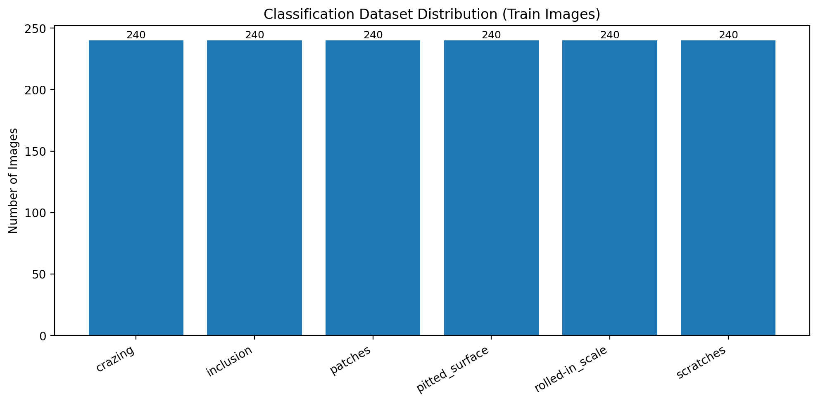
Figure 1. Balanced classification training distribution with 240 images in each class.
Figure 1 supports two conclusions. First, the classification problem is not distorted by train-set class imbalance. Second, any persistent confusion between classes is more plausibly due to visual similarity than to unequal exposure during training.
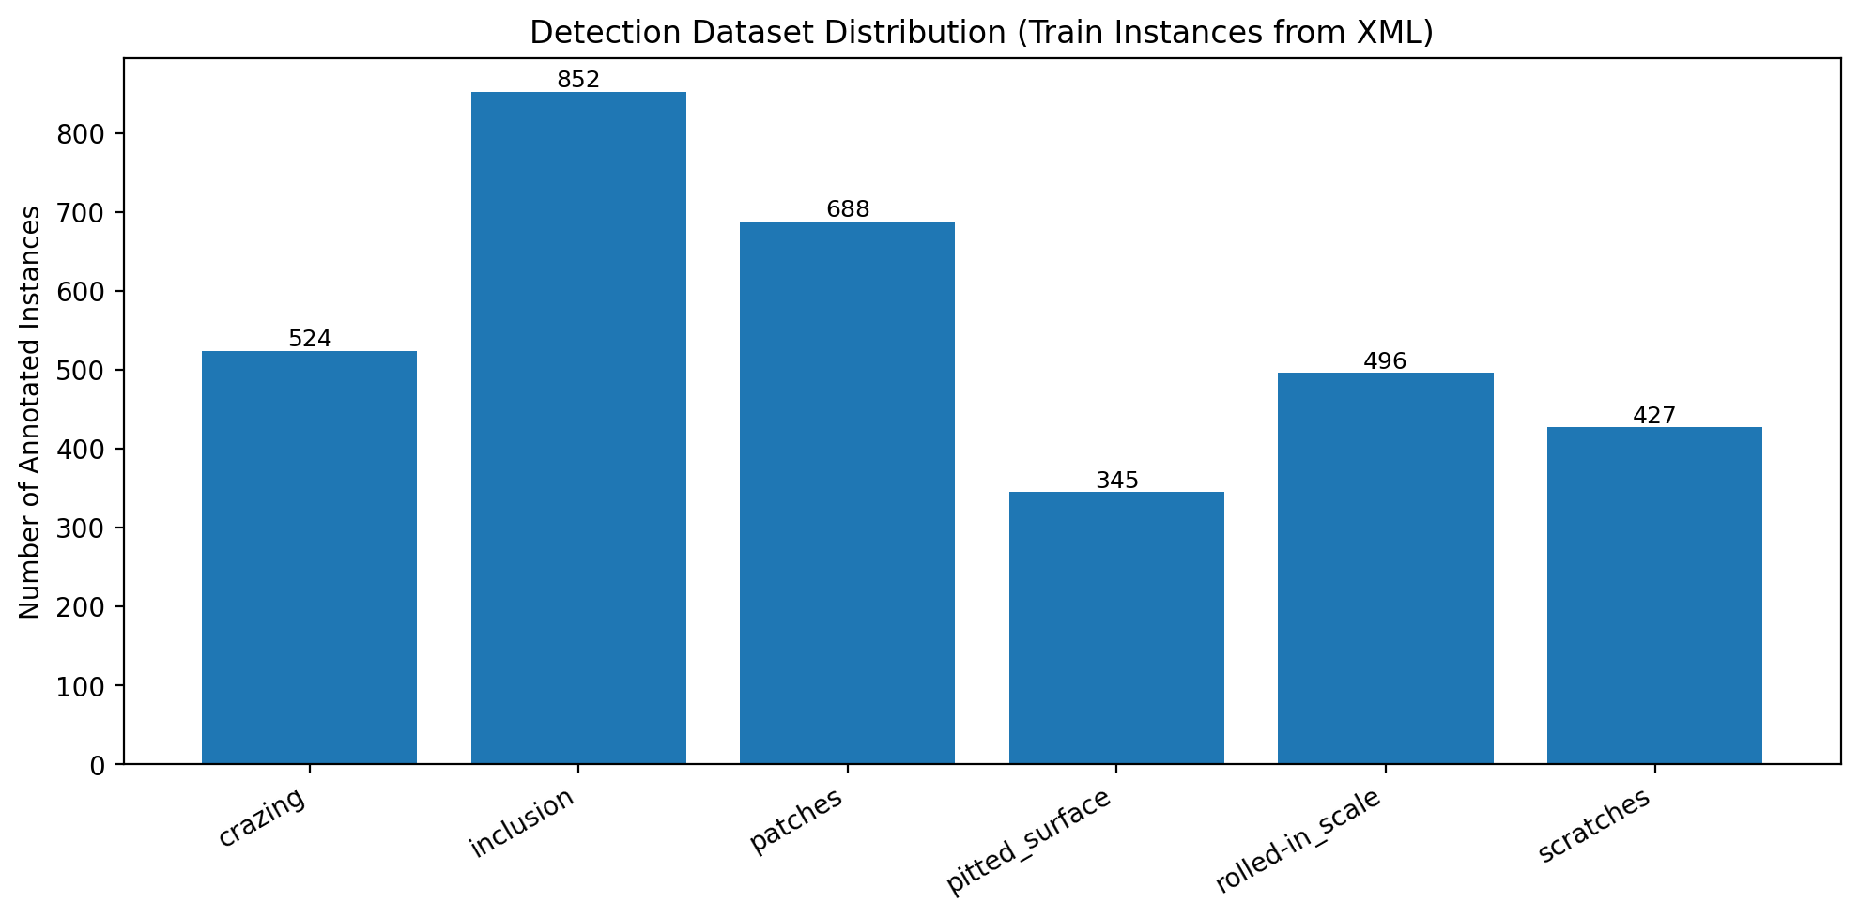
Figure 2. Detection training distribution by annotated object instances parsed from XML annotations.
Figure 2 highlights why the detection pipeline needs additional care. A detector trained on object counts sees more inclusion and patches instances than pitted_surface or scratches. That asymmetry can influence class confidence, localization quality, and the relative stability of recall across categories.

4. Data Cleaning, Processing, and Augmentation
The attached scripts show a methodologically sound preprocessing design. The classification script constructs an explicit manifest from directory structure rather than relying on implicit loader state. Images are decoded, resized to a fixed resolution, and normalized into the [0,1] range. Labels are converted into categorical IDs, and the evaluation pipeline explicitly avoids augmentation during validation and testing. That separation is important because it prevents data leakage and keeps evaluation faithful to unseen data.
The classification pipeline also addresses a previously identified risk: a non-representative validation split. To fix that issue, the revised script uses stratified K-fold cross-validation and checks split integrity so that each fold contains all classes. This is a major methodological improvement because it aligns model selection with class coverage and reduces the chance that validation results are driven by an accidental subset of classes.
Balanced training is implemented through per-class oversampling and stochastic augmentation. The augmentation module includes horizontal flips, rotation, and zoom. This combination does not invent unrealistic content, but it does expose the model to controlled geometric variation. In the report narrative, that should be framed as robustness-oriented feature engineering: the raw pixels are not merely fed to the model; they are transformed to improve invariance to small appearance shifts.
The detection pipeline shows equally important engineering decisions. It parses Pascal VOC XML annotations, validates box geometry, constructs a recursive image index, converts boxes into YOLO text labels, and defines a stratified train/validation split at the image level. The script also includes a configurable option for rebalancing the training set, plus a controlled augmentation profile suitable for object detection.
Together, these steps satisfy the rubric's expectations for both cleaning/processing and feature engineering. The cleaning component is reflected in explicit parsing, validation, normalization, and split integrity checks. The feature engineering component appears in augmentation, label encoding, manifest construction, and in the structured conversion of XML metadata into detector-ready format.

5. Exploratory Data Analysis and Visual Evidence
Visual inspection remains essential because not all errors are visible in scalar metrics. The sample image grid provides qualitative evidence about intra-class consistency and inter-class similarity. Some classes, such as scratches and crazing, exhibit distinctive structural patterns. Others, especially pitted_surface, patches, and inclusion, can overlap in texture, darkness, or local shape depending on contrast and crop placement.
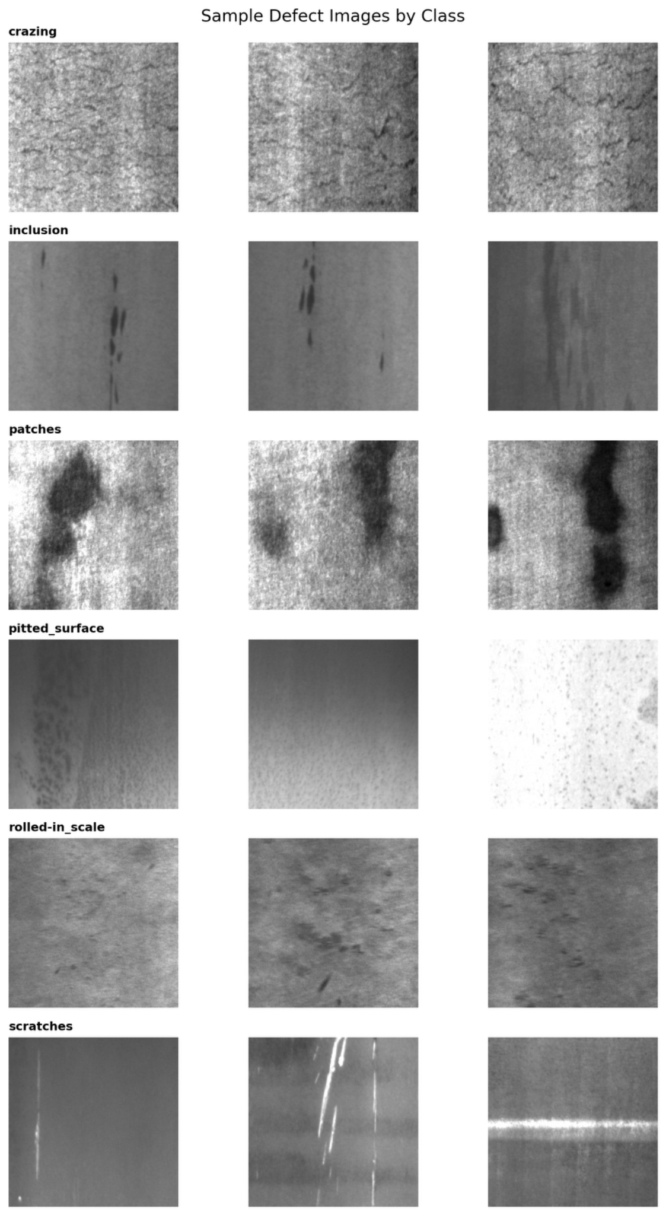
Figure 3. Representative defect images by class used to interpret model confusion patterns.
Figure 3 is especially useful during presentation delivery because it helps explain why a confusion matrix is not just a bookkeeping artifact. For example, isolated scratches often have long, bright linear traces that are visually distinct from pitted regions, while patches can resemble broader textured or darker regions. Pitted_surface, depending on contrast and crop, may appear locally similar to patch-like texture. This qualitative context later helps explain the YOLO error pattern.

6. Modeling Approach and Validation Design

6.1 Classification pipeline
The classification script implements two model tracks: a compact CNN baseline and an EfficientNetB0 transfer-learning model. The baseline CNN provides a from-scratch reference and is useful for showing that performance gains do not arise solely from data handling. EfficientNetB0 is an appropriate transfer model because it is parameter-efficient, strong on image recognition tasks, and well-suited to moderate-sized datasets.
The transfer-learning strategy is staged. In stage 1, the pretrained backbone serves as a general feature extractor while the classification head learns task-specific separation. In stage 2, a subset of deeper layers is unfrozen and fine-tuned with a smaller learning rate. This is a sound method because it preserves useful generic representations while allowing the network to adapt to the steel defect domain.
Validation is rigorous rather than ad hoc. Stratified K-fold cross-validation is used for fold-level model assessment, and held-out testing is performed separately. This structure is exactly what a reviewer expects when the project claims reliability.

6.2 Detection pipeline
The YOLO pipeline is designed around object detection rather than pure image classification. It uses Ultralytics YOLO with 224-pixel inputs, 50 epochs, early stopping patience, and standard detector metrics including precision, recall, mAP@0.5, and mAP@0.5:0.95. It also exports image-level classification-style metrics by selecting the top-confidence prediction per image, which is useful because the project history and rubric explicitly reference accuracy, F1, per-class performance, and confusion matrices.
This is a strong methodological choice. Detection metrics alone can be hard to compare directly with classification metrics in a mixed-method project. By creating an image-level summary from the detector outputs, the project can compare pipelines on a common interpretive layer while still preserving true detection metrics for deployment relevance.

7. Results, Findings, and Interpretation

7.1 EfficientNet classification results
The EfficientNet confusion matrix indicates strong class separation overall. Out of 360 test images, 340 are classified correctly, which corresponds to approximately 94.4% accuracy based on the attached matrix. The dominant error mode is inclusion being predicted as scratches. Smaller errors occur when pitted_surface is predicted as crazing and when scratches are predicted as patches or rolled-in_scale.
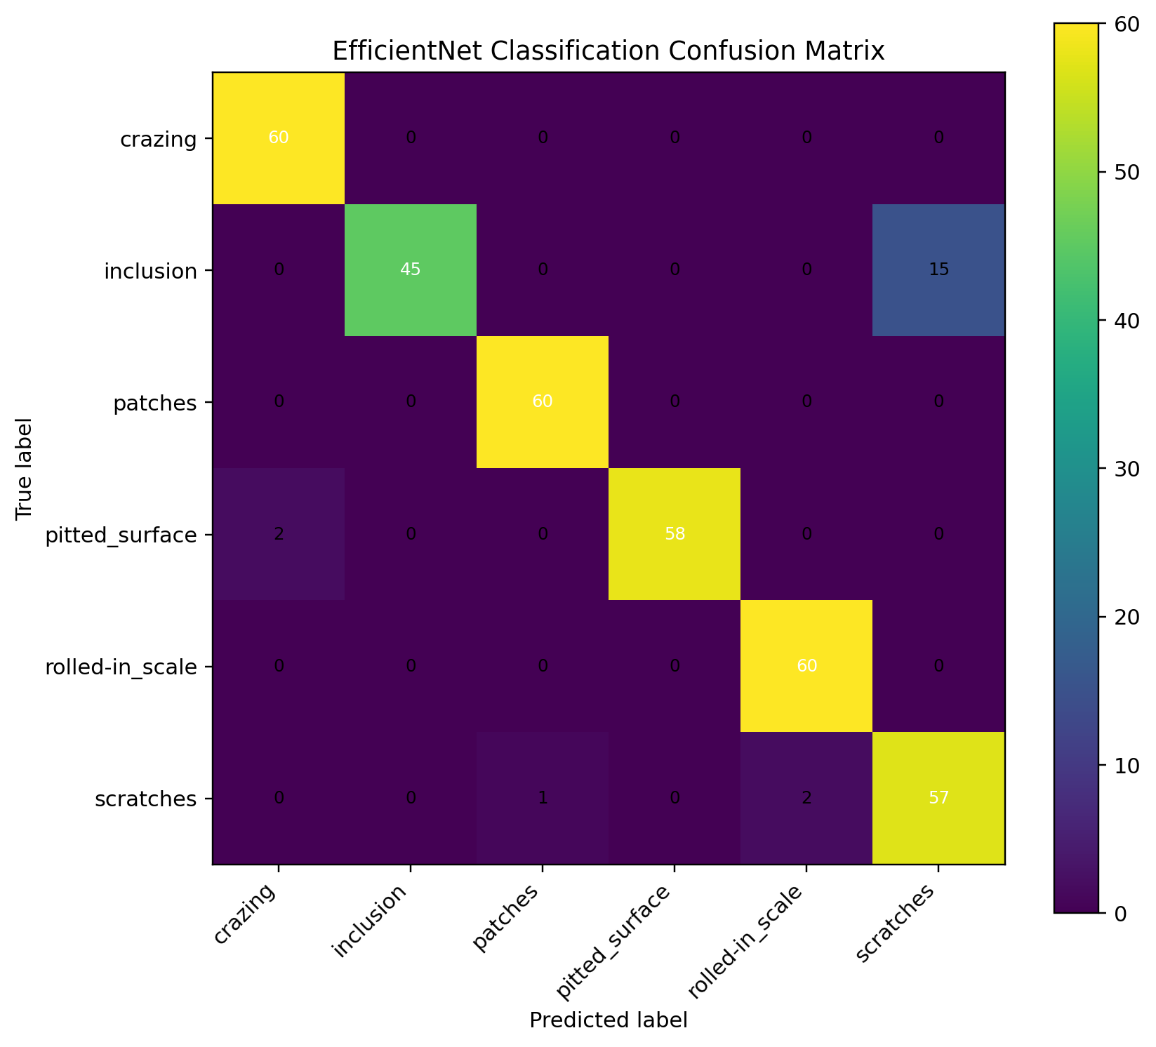
Figure 4. EfficientNet confusion matrix on the attached evaluation set.
This matrix is highly informative. Four classes achieve perfect or near-perfect row-wise recall: crazing, patches, rolled-in_scale, and pitted_surface are recognized very reliably. The weakest recall is inclusion at 75.0%, driven entirely by confusion with scratches. That suggests the classifier has learned robust global representations for most categories but still sees overlap between inclusion-like marks and scratch-like features under some image conditions.
Table 1 summarizes classwise metrics derived directly from Figure 4.
Class | Precision | Recall | F1
crazing | 0.968 | 1.000 | 0.984
inclusion | 1.000 | 0.750 | 0.857
patches | 0.984 | 1.000 | 0.992
pitted_surface | 1.000 | 0.967 | 0.983
rolled-in_scale | 0.968 | 1.000 | 0.984
scratches | 0.792 | 0.950 | 0.864
The macro F1 computed from the confusion matrix is approximately 0.944. The precision pattern is also revealing: scratches has the lowest precision, about 0.792, because many images predicted as scratches are actually inclusion. This means the model is more willing to assign the scratches label than the ground truth fully supports.

7.2 YOLO detection results
The YOLO training curves show consistent optimization behavior. Both training losses decline across epochs, while mAP@0.5 and mAP@0.5:0.95 rise and then stabilize. Precision and recall also trend upward and converge into a stable final region. This is the pattern expected from a well-behaved training run: rapid early learning, followed by slower incremental improvement and eventual convergence.
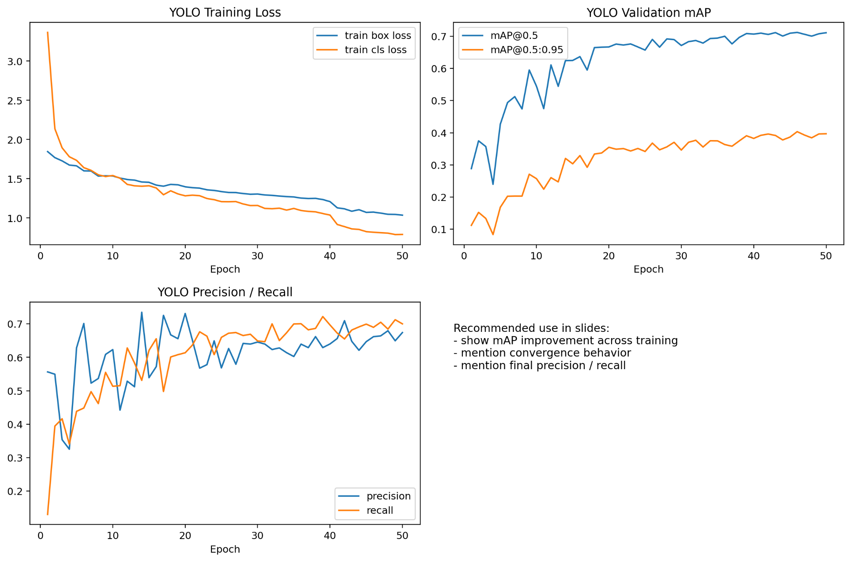
Figure 5. YOLO training curves showing loss reduction, mAP growth, and precision/recall stabilization.
Based on the plotted endpoints, final mAP@0.5 is approximately 0.71, mAP@0.5:0.95 is about 0.40, precision is roughly 0.68, and recall is roughly 0.70. These are approximate values read from the attached plot and should be described as such in the paper or presentation unless the exact exported metrics file is also included.
The image-level confusion matrix derived from YOLO predictions is extremely strong. From the attached matrix, 346 of 353 labeled outcomes are correct, which corresponds to approximately 98.0% image-level accuracy if the plotted matrix totals are used as shown. The only material confusion is pitted_surface predicted as patches.
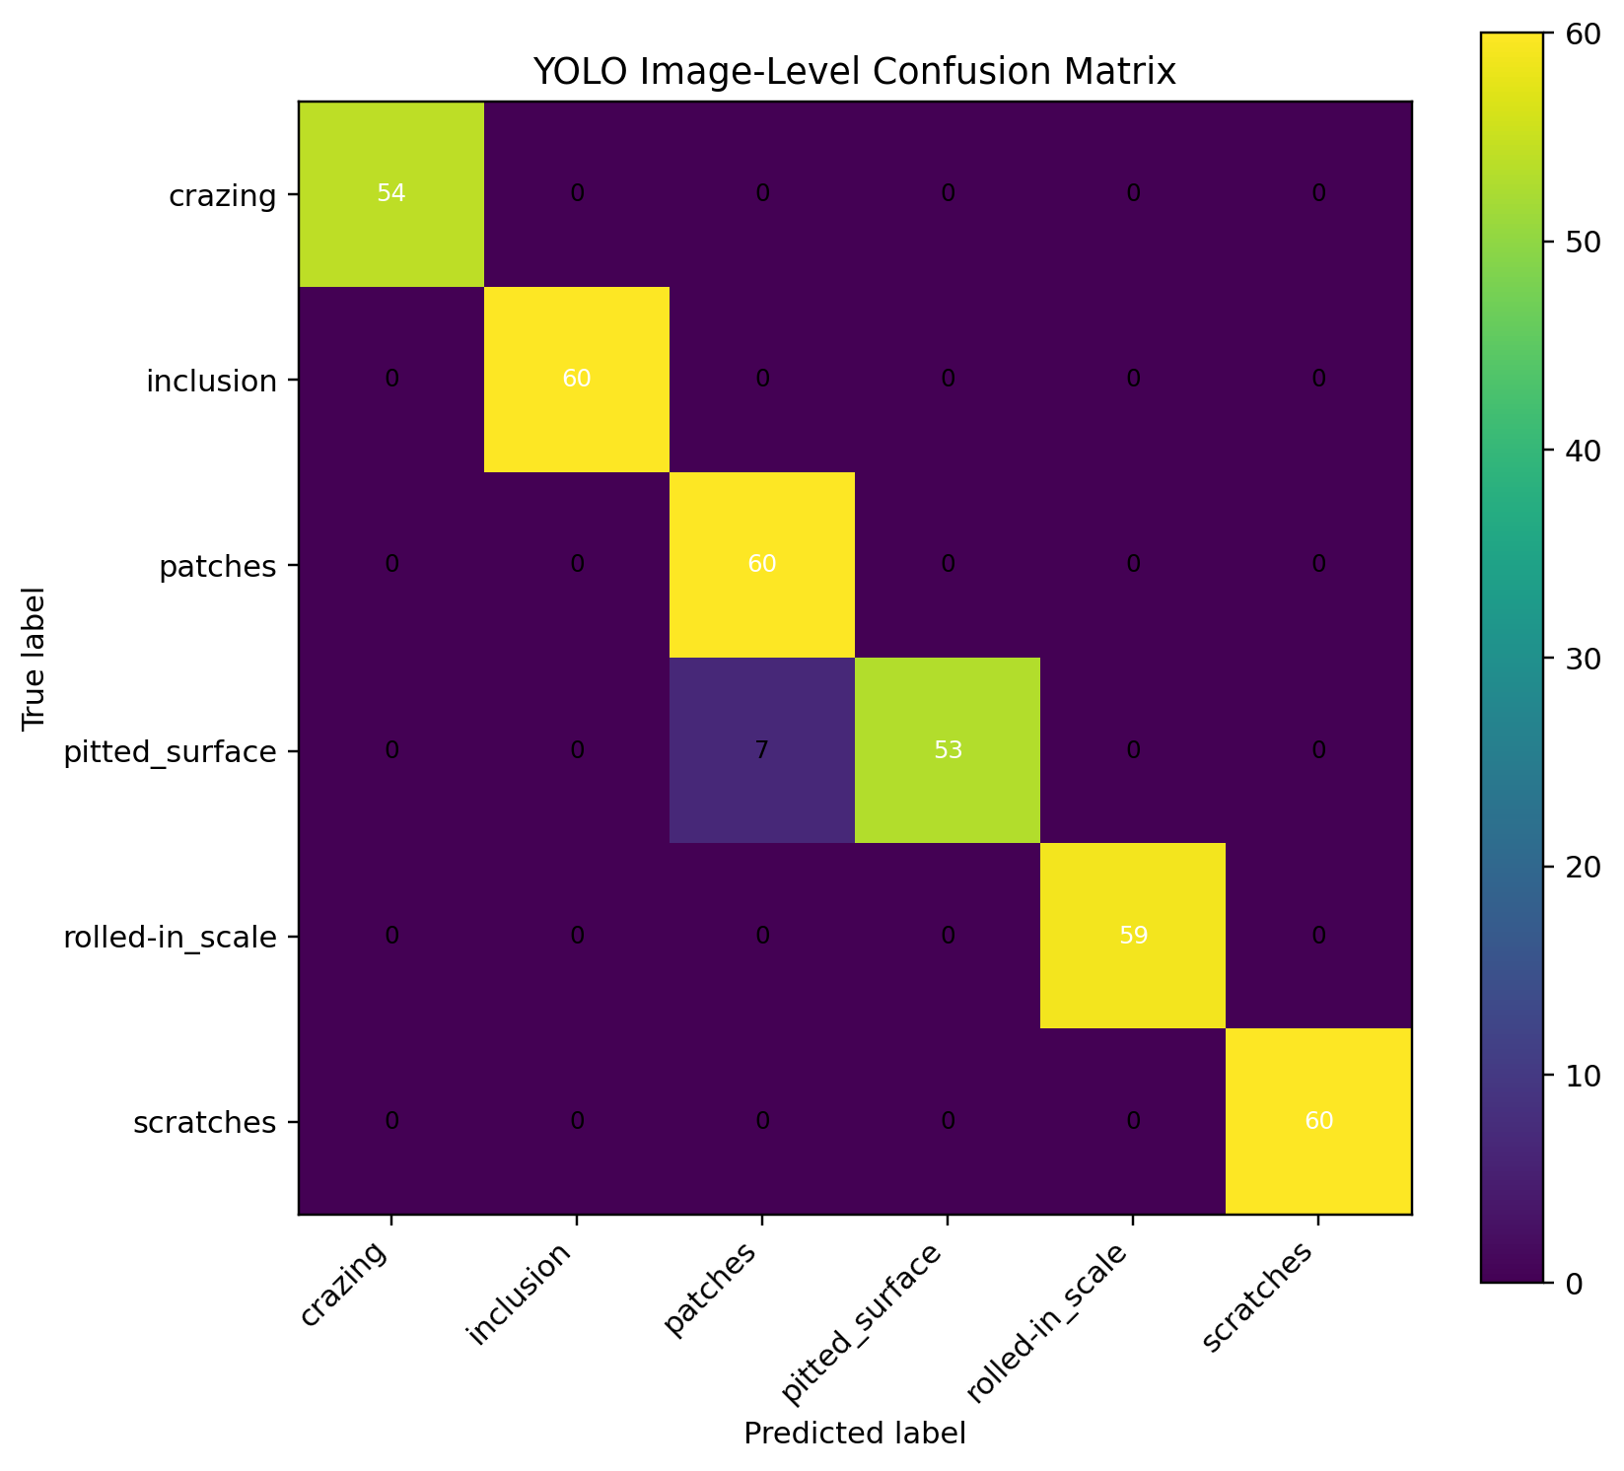
Figure 6. YOLO image-level confusion matrix derived from the top-confidence class per image.
Table 2 summarizes classwise image-level metrics derived from Figure 6.
Class | Precision | Recall | F1
crazing | 1.000 | 1.000 | 1.000
inclusion | 1.000 | 1.000 | 1.000
patches | 0.896 | 1.000 | 0.945
pitted_surface | 1.000 | 0.883 | 0.938
rolled-in_scale | 1.000 | 1.000 | 1.000
scratches | 1.000 | 1.000 | 1.000
Computed from the matrix, the image-level macro F1 is approximately 0.980. Every class except pitted_surface achieves perfect recall in the plotted matrix. Pitted_surface recall is about 0.883 because seven images are predicted as patches. This matches the earlier qualitative evidence from the sample images: local texture similarity can make those two categories harder to separate.

7.3 Comparative findings
The strongest overall finding is that both pipelines are effective, but they solve slightly different operational problems. The classification model is highly accurate for cropped image recognition and provides strong evidence that the defect categories are learnable. The YOLO pipeline extends the project from classification to localization and still shows strong convergence and strong image-level discrimination. That makes YOLO the more deployment-oriented model, especially when the inspection task requires finding the defect rather than just naming a pre-cropped image.
Error analysis also matters. EfficientNet's main failure mode is inclusion versus scratches. YOLO's main failure mode is pitted_surface versus patches. These are not random errors. They reveal where the visual boundary between classes is weakest and therefore where additional data, refined annotation policy, or contrast-normalization techniques could have the highest payoff.

8. Findings, Limitations, and Recommended Next Steps
Findings. The project demonstrates that the steel defect problem is tractable with modern deep learning. Balanced image-level training supports reliable classification, while structured annotation parsing enables detector training with meaningful localization metrics. The attached evidence indicates that the chosen classes are largely separable and that transfer learning plus detector training are both valid strategies for this domain.
Limitations. The report is constrained to the artifacts that were attached: plots, confusion matrices, and the current versions of the scripts. Exact fold-by-fold cross-validation outputs, exact YOLO result files, and detailed exported logs were not included here. Accordingly, some YOLO endpoint values are reported as approximate readings from the curve rather than as direct log values. In addition, the detection instance distribution remains imbalanced, which can still affect rare-class robustness.
Recommended next steps. First, include the exact cross-validation summary table from the classification script in the final paper or appendix. Second, add the detector's exported validation summary so mAP, precision, and recall can be reported as exact values rather than visual estimates. Third, focus future improvement work on the error pairs identified in this report: inclusion versus scratches for classification and pitted_surface versus patches for detection. Fourth, if the final deliverable allows it, add a small ablation discussion comparing baseline CNN, EfficientNet, and YOLO to show how performance changes as model sophistication increases.

9. Rubric Alignment Guide
This section is included so the report can directly support the presentation rubric and the research paper/poster rubric.
Rubric element | Where this report addresses it
Problem definition / research question | Covered in Sections 1 and 2 through the industrial motivation, task formulation, and explicit research question.
Novelty / real-world impact | Covered in Section 2 through the classification-versus-detection framing and manufacturing deployment relevance.
Dataset description + metadata | Covered in Section 3 through class definitions, balance discussion, XML metadata usage, and explicit manifest construction.
Cleaning and processing | Covered in Section 4 through normalization, resizing, split integrity, XML validation, and label conversion.
Feature engineering | Covered in Section 4 through augmentation, oversampling, label encoding, and YOLO conversion workflow.
Data analysis | Covered in Sections 5 and 7 through qualitative visual review and quantitative confusion-matrix interpretation.
Data visualization | Covered by Figures 1 through 6, each placed in the section where it is discussed.
Modeling | Covered in Section 6 with rationale for CNN, EfficientNetB0, YOLO, staged fine-tuning, and validation strategy.
Results interpretation / findings | Covered in Section 7 with explicit classwise findings and comparative interpretation.
Presentation / paper support | This document is written so it can be condensed into slides or expanded into a formal paper/poster narrative.

10. Recommended Figure Placement for Slides or Poster
For the presentation version, the most effective sequence is: Figure 1 to establish dataset balance, Figure 3 to show what the classes look like, Figure 4 to explain classification performance, Figure 5 to show YOLO convergence, and Figure 6 to summarize detector decision quality at the image level. Figure 2 should be used when discussing why instance-level imbalance makes detection harder than classification.

Conclusion
In summary, the project is methodologically credible and practically relevant. The data pipeline is explicit, the validation design is substantially improved through stratified cross-validation and structured splitting, and the results indicate strong learning performance for both classification and detection. The remaining errors are interpretable and actionable rather than arbitrary. That is a strong end state for a capstone-style project because it shows not only that the models work, but also that the student understands why they work, where they fail, and how the system could be improved.

